* This project is done on the AWS platform

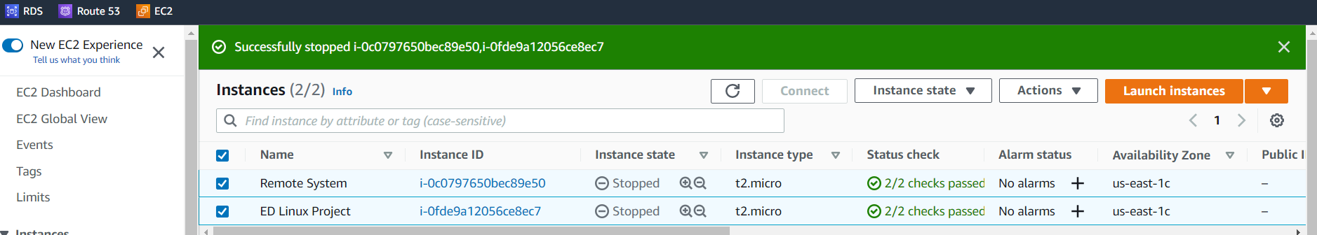

* 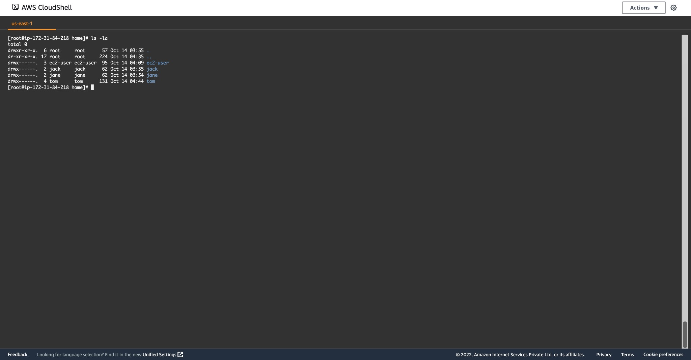Tom creates user accounts for Jane and Jack in his system.

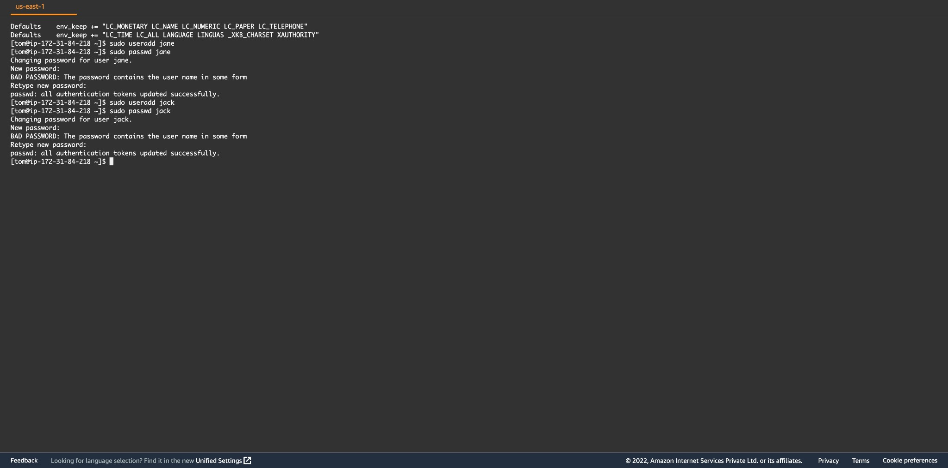

* Separate home directories are created for each of the three users. ● They have a common repository script where every user has access to view and edit files.

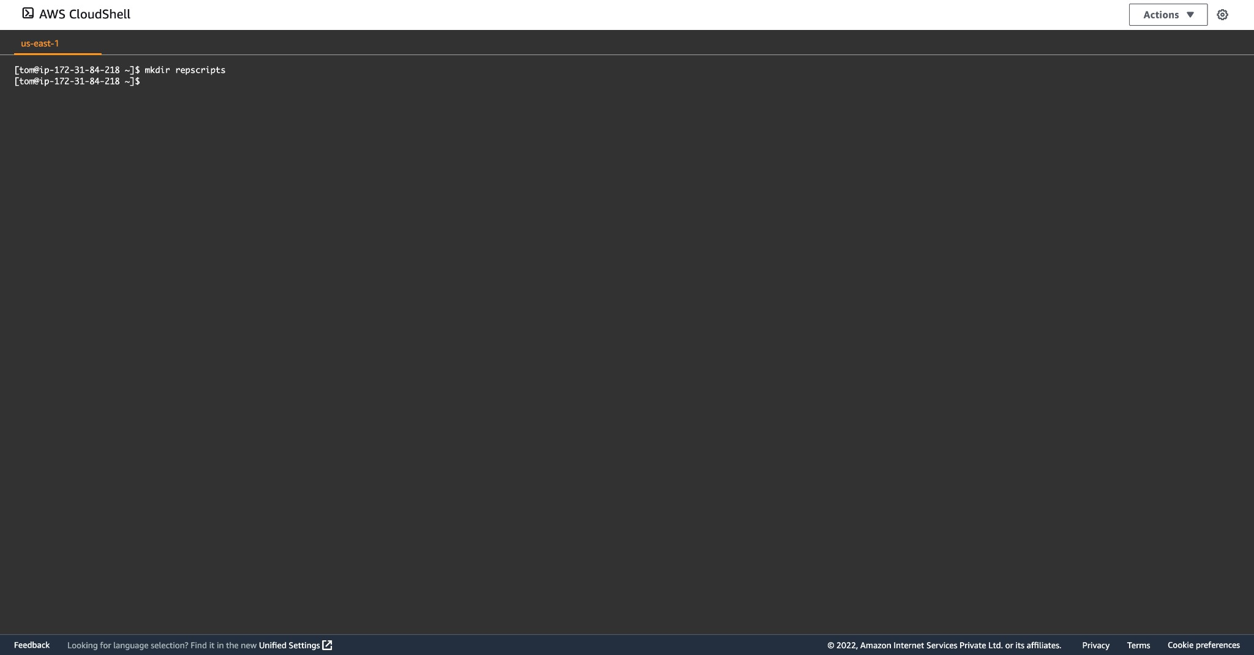

* Tom installed git as the SCM in a remote system.

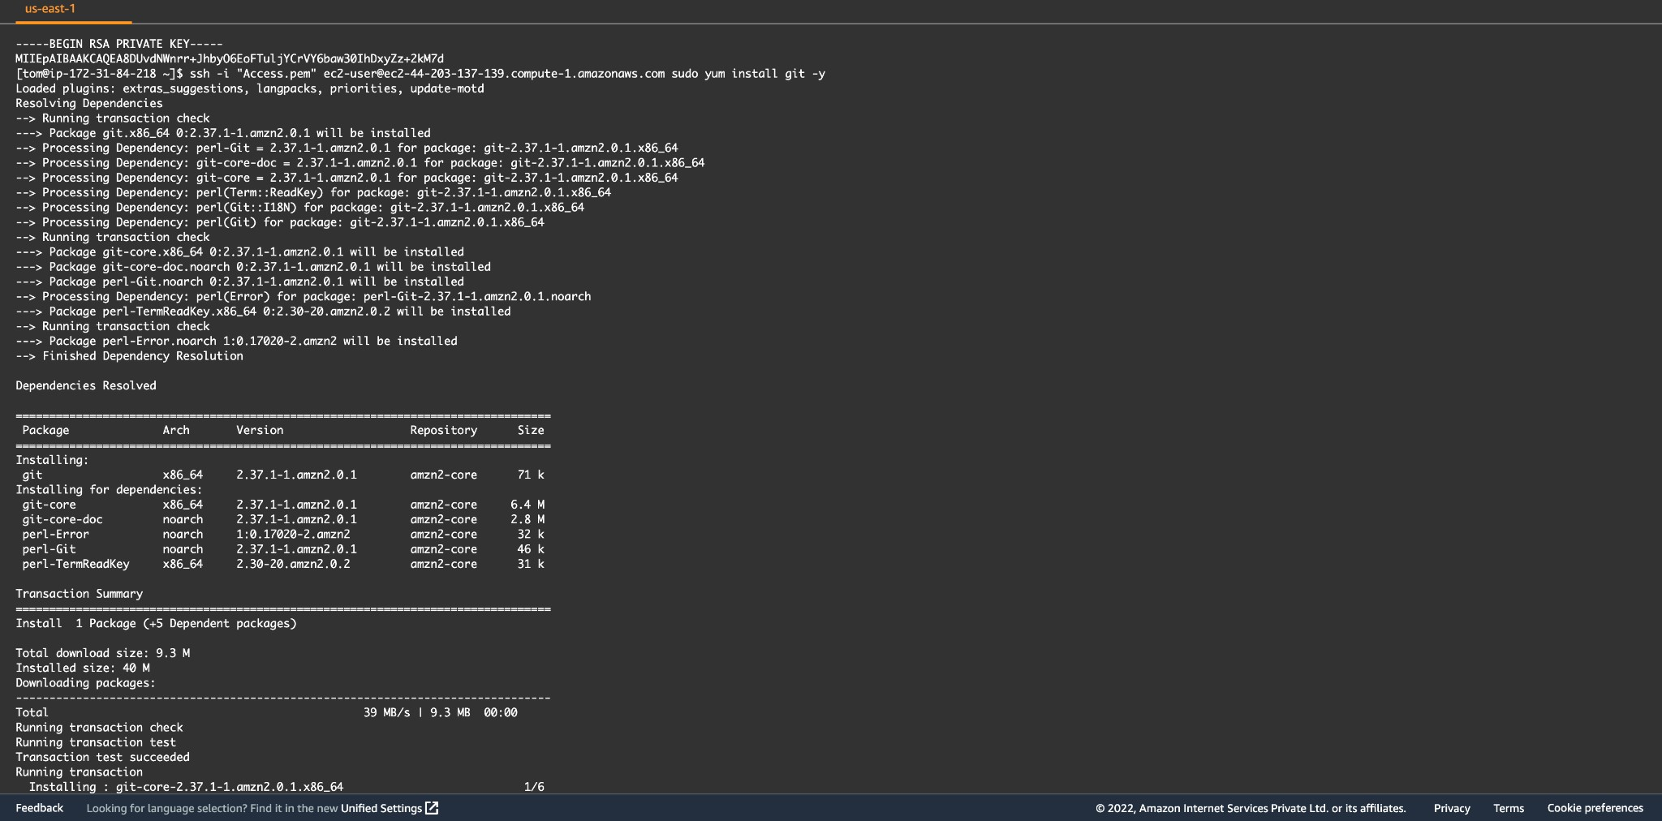

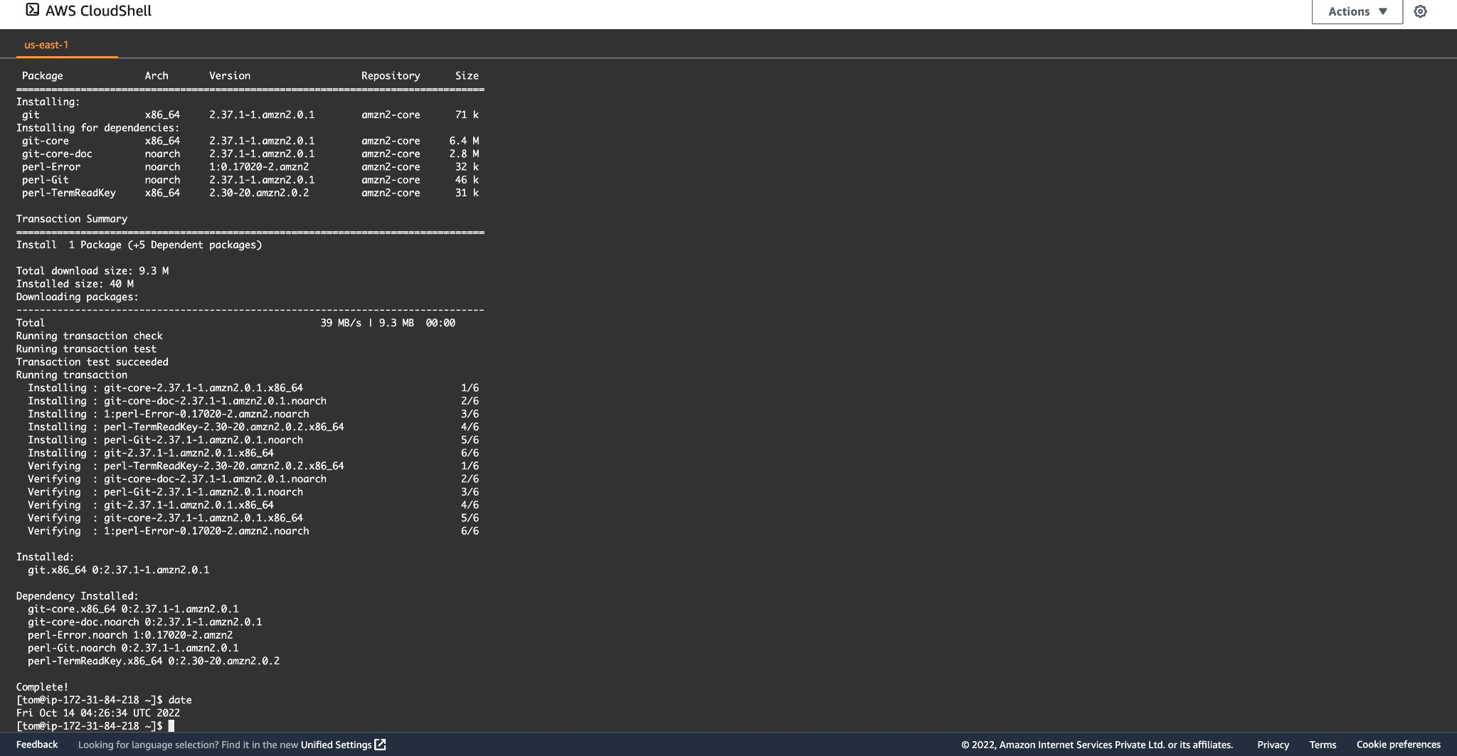

* He set a cron job to delete empty files and directory from /tmp folder at 00:00 am. ● He set a cron job to upgrade the system every week on Tuesday 6:00 am.

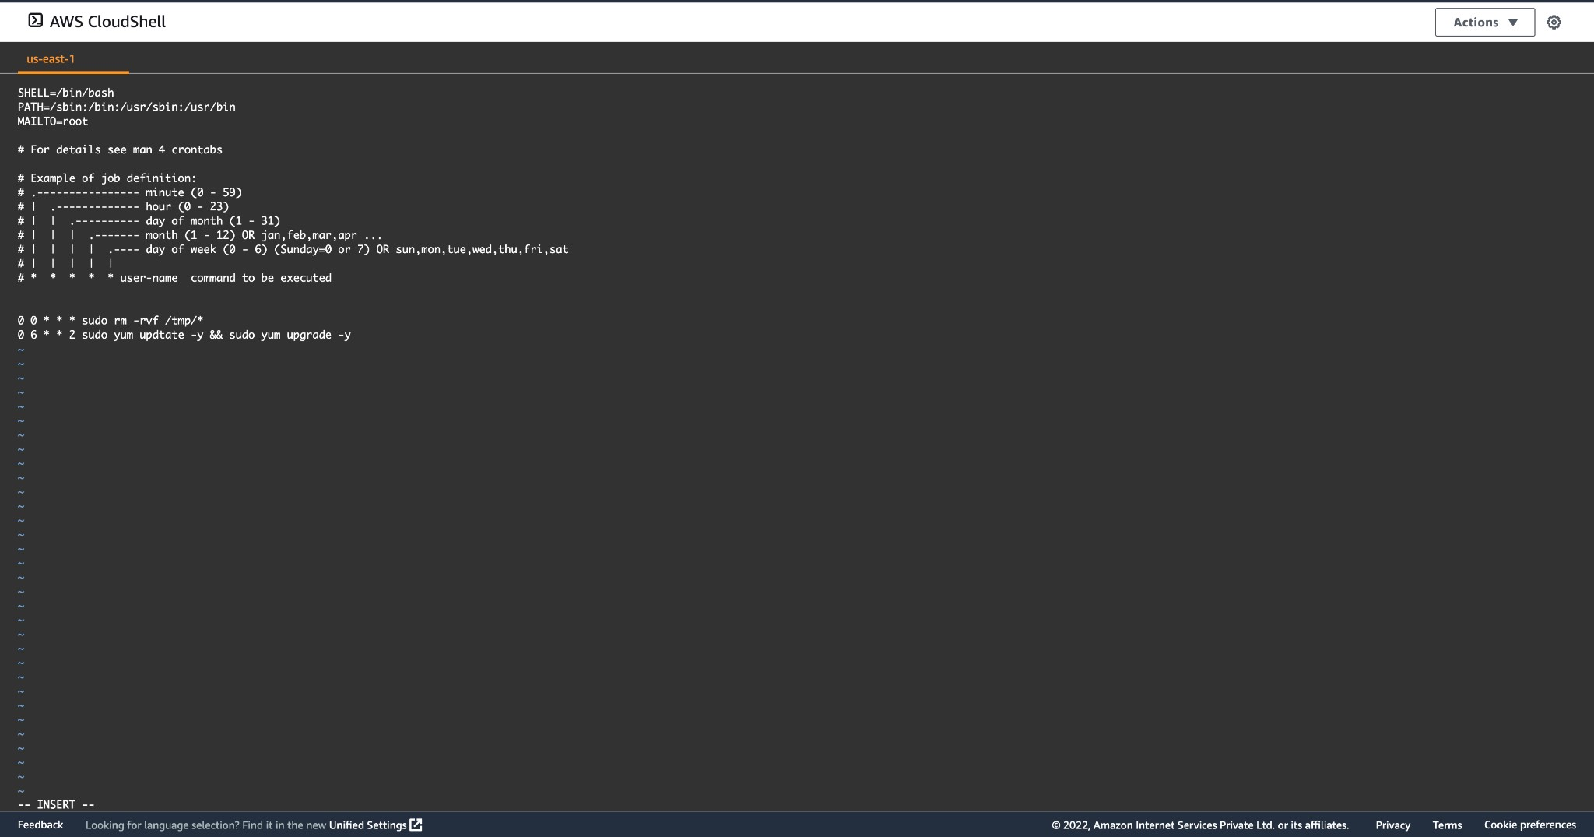

* 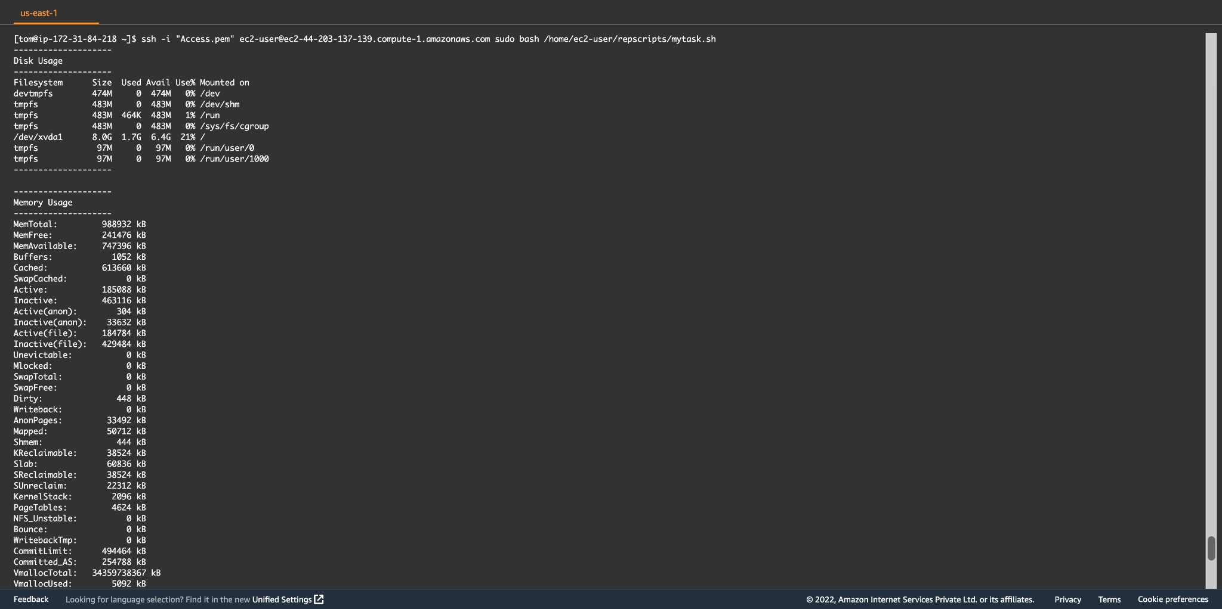Tom creates a script which has functionalities to display CPU load, Memory usage,disk usage, network usage, active logged in users.

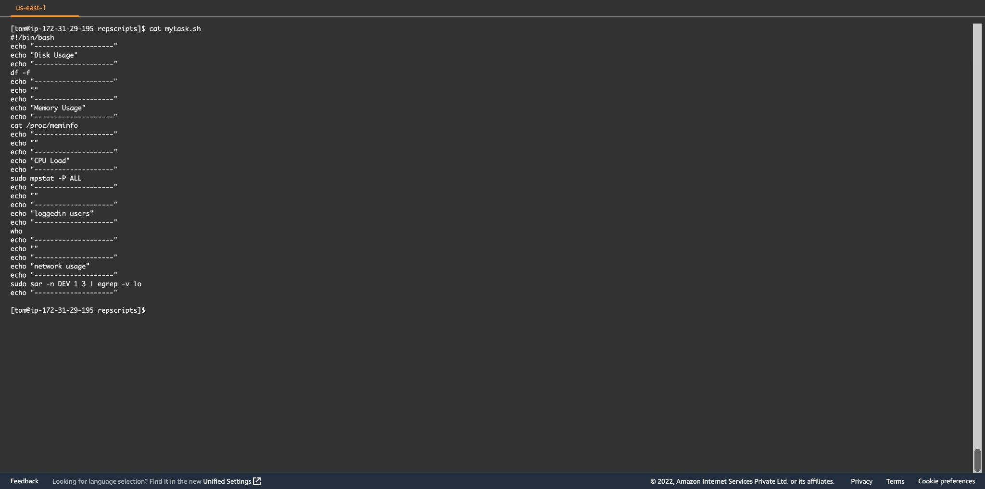

* He runs the scripts to get data for remote server to check and maintain the remote server from his desktop.

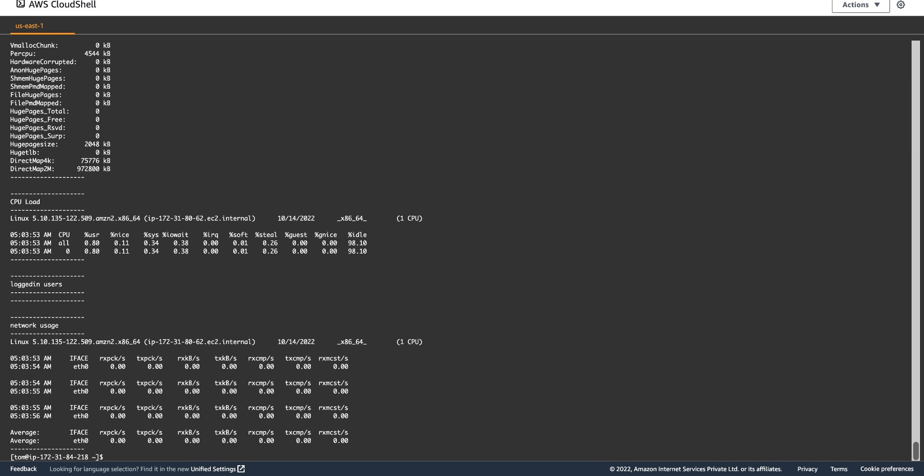

* He restricts users to access youtube from this machine.

